

**Please complete this on your child’s computer to allow access during school time. This is important and speeds up the “onboarding” time.**

**How to remove a device out of “S Mode”**



1. Click on Windows Start button (Bottom left of the screen) > Click Settings on the left hand side above the power button > Select the System tab on the left hand pane.

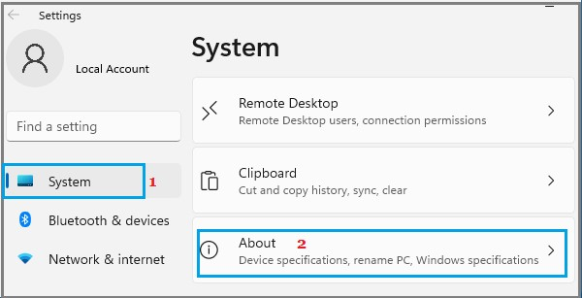

1. On About screen, scroll down and click on Product key and Activation tab, located under Related Settings.

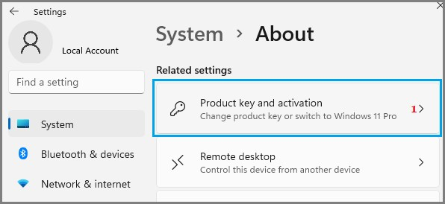

1. On the next screen, expand the S Mode entry and click on Open Store button.

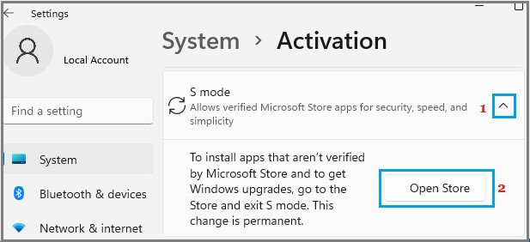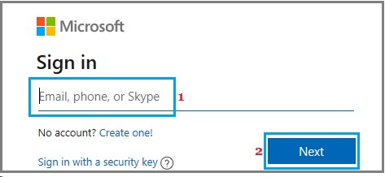

(If you are not signed-in to a Microsoft Account, you will be prompted to Sign-in to Windows Store using your Microsoft Account. **This is your personal account and not your student’s school account**

1. On the next screen, click on the Get button to switch your computer out of S Mode.

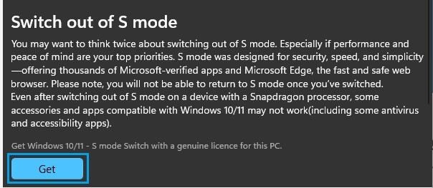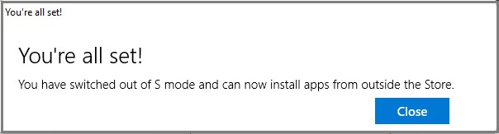

1. Once S Mode is switched OFF, you will see a pop-up, confirming that S Mode has been switched OFF and you can now install Apps from outside Microsoft Store on your computer.

If you require any help, please email the school’s IT Department: IThelpdesk@birkdalesouthss.eq.edu.au

**\* What is windows “S Mode”?**

Windows 11 S Mode enhances the security of your device by limiting App downloads to Microsoft Store, effectively blocking installation of all third-party Apps & Programs on your computer. This includes the Education Queensland software required to setup the device on the EQ network.