

**Setting up a Windows 11 Laptop – “Onboarding with InTune” guide 3 of 3 (v1.0)**

Before starting, you will require your students school username and password. If your student has not yet attended school, these details will not be available until 2-3 days after their first day attending. You can ask your child’s teacher for these details after they have first attended.

NOTE: Your childs account on the computer that they will be using **must be set as an administrator of the device.** If you are unsure how to do this, refer to guide 2 “Create a student account” follow step 1, 2, 3 and 8. The device will not download all the necessary applications and wireless settings if this is not done.

Step 1: Go to settings – 1. Press the “Start” button. 2. Type “Settings” (No need to click anything, just start typing). 3. Click on the “Settings” app when it appears.

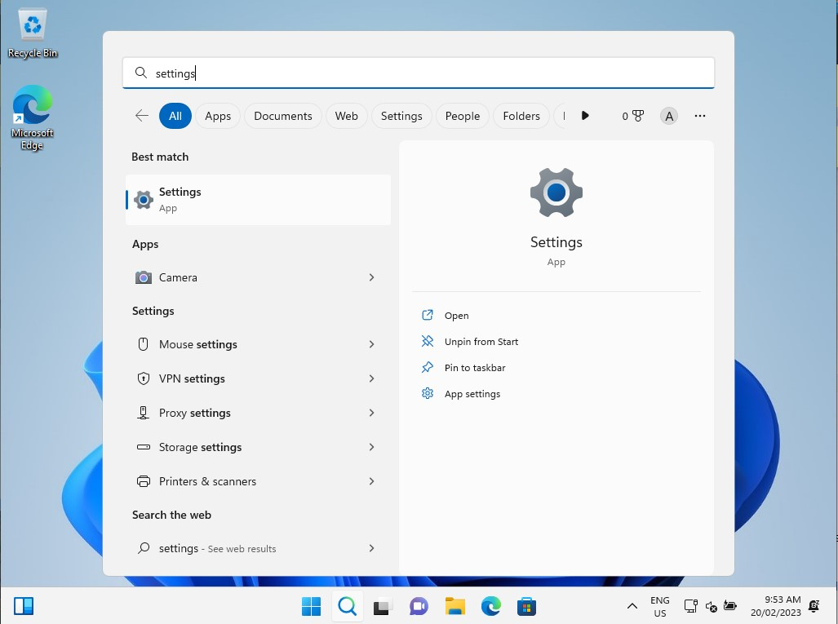

1

2

3

Step 2: Go to Accounts – Select “Accounts” on the left-hand side of the page

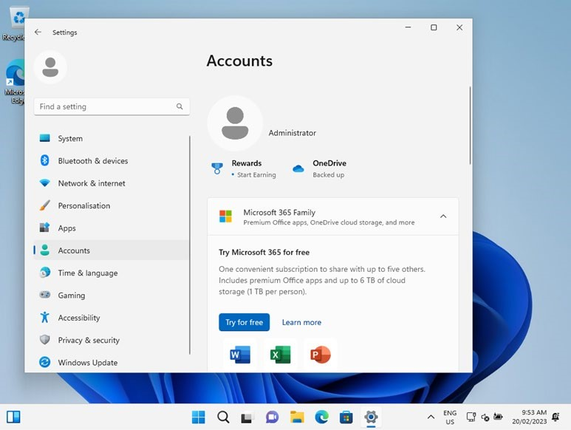

Step 3: Select **Access work or school**

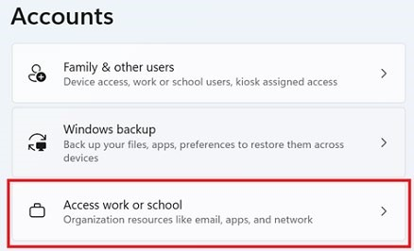

Step 4: Enter your child’s school *username* followed by @eq.edu.au and click “Next”

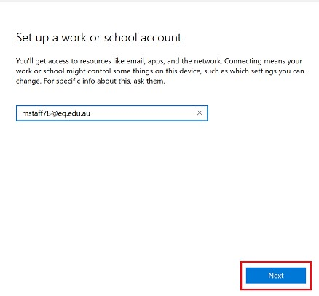

Step 5: Please enter your students username, password, accept the terms and conditions and **Sign in**.

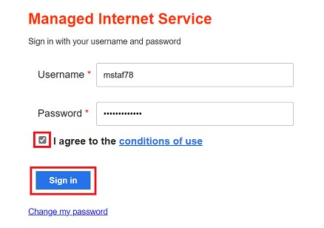

Step 6: Please select **Done**.

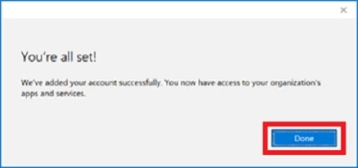

Step 7: Check your account has been added. Your account details will be displayed.

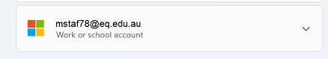

Your child’s device has now been setup to work the Education Queensland network!

**Now some apps are required to be installed. Please wait 5-10 minutes before completing the next step to allow time for the computer to finish the setup in the background.**

Step 1: Go to Company Portal - 1. Press the “Start” button. 2. Type “Company Portal” (No need to click anything, just start typing). 3. Click on the “Company Portal” app when it appears and click Open if necessary. Company Portal may ask you to sign in again, if so, please sign in again using your childs username and password.

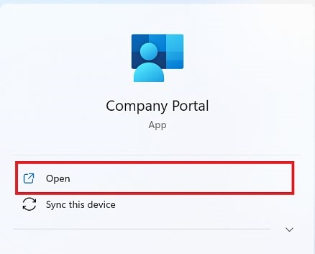

Step 2: The only app required to be installed at home is BYOx Mapper – Click on “BYOx Mapper**” NOTE: If BYOx mapper does not show, it may mean the device is in “S Mode”. Before you can continue, you will need to remove S Mode from the laptop.** [**How to remove S Mode from your device instructions**](https://pallarass.eq.edu.au/SupportAndResources/FormsAndDocuments/Documents/BYOD/remove-device-out-of-s-mode.pdf)

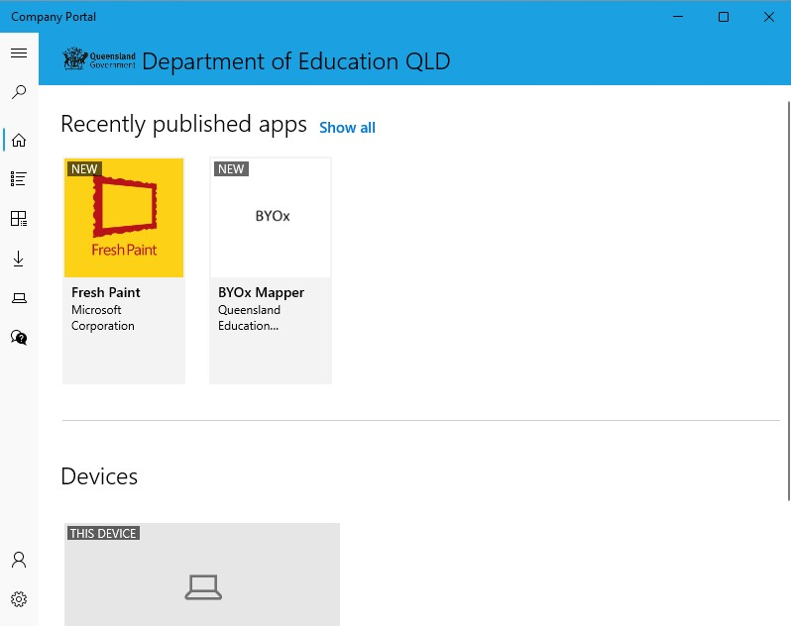

Step 3: Click “Install”

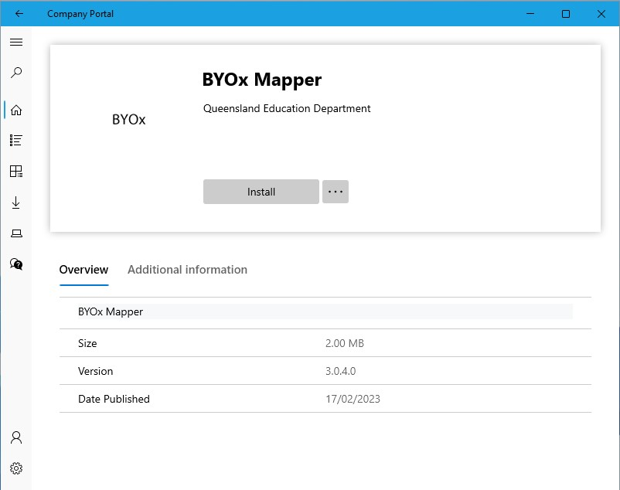

You are done!

If for whatever reason you need help or are having issues, please let your child’s teacher know to log a job with the ICT Department. For any questions or concerns, you can also email our ICT staff at [IThelpdesk@birkdalesouthss.eq.edu.au](mailto:IThelpdesk@birkdalesouthss.eq.edu.au) or come by to the BYOd Help desk (located in the Library).